Peer-graded Assignment: Analysing Historical Stock/Revenue Data and Building a Dashboard

Question 1 - Extracting Tesla Stock Data Using yfinance - 2 Points

Question 2 - Extracting Tesla Revenue Data Using Webscraping

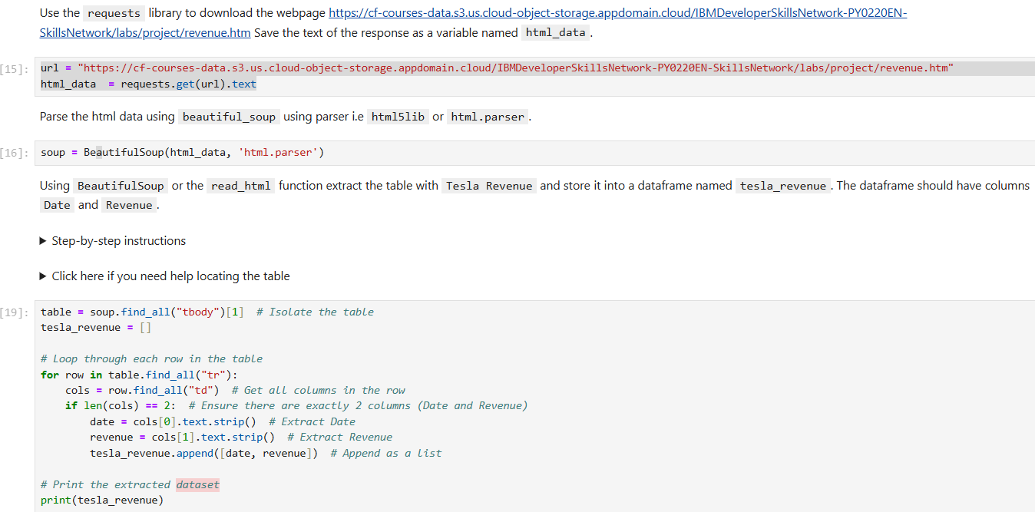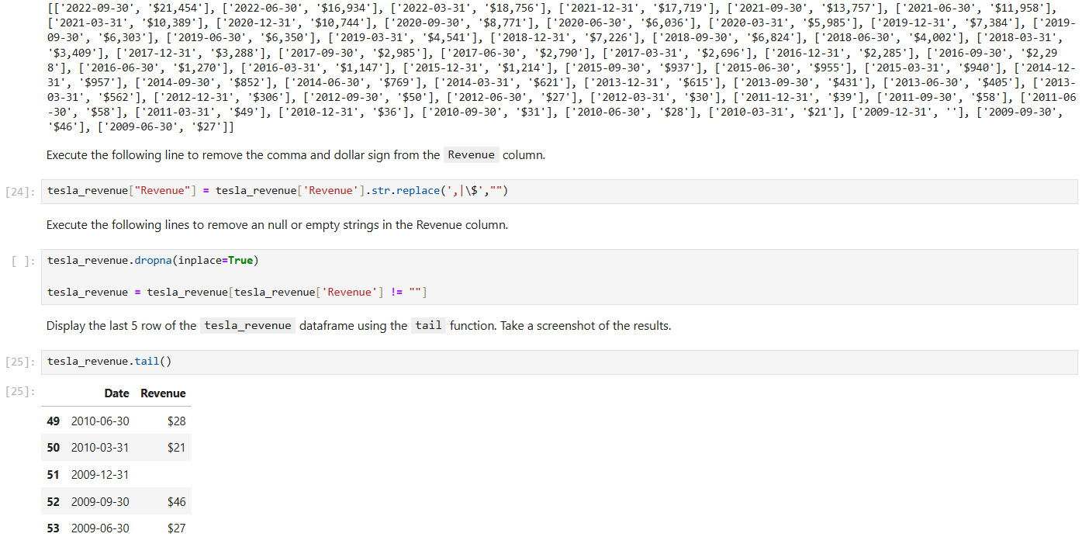

Question 3 - Extracting GameStop Stock Data Using yFinance

Question 4 - Extracting GameStop Revenue Data Using Webscraping

Question 5 – Tesla Stock and Revenue Dashboard

Question 6 – GameStop Stock and Revenue Dashboard

Question 7 – Sharing your Assignment Notebook